Experiment – 6: Data Visualization Using Power BI
AIM:
To visualize and analyze business sales data using Power BI by creating interactive dashboards consisting of various charts and graphs.
Dataset Used:
IPL Player Stats Dataset
(Contains columns: Player, COUNTRY, TEAM, AGE, CAPTAINCY EXP, Paying_Role, Mat, Inns, Runs, BF, HS, Avg, SR, NO, 4s, 6s, 0s, 50s, 100s, TMat, TInns, TRuns, TBF, THS, TAvg, TSR, TNO, T4s, T6s, T0s, T50s, T100s, B_Inns, B_Balls, B_Runs, B_Maidens, B_Wkts, B_Avg, B_Econ, B_SR, B_4w, B_5w, B_TInns, B_TBalls, B_TRuns, B_TMaidens, B_TWkts, B_TAvg, B_TEcon, B_TSR, B_T4w, B_T5w, SOLD_PRICE, etc.)

PROCEDURE:
1) Importing Dataset into PowerBI desktop
Steps:
- Open Power BI Desktop.
- Click on “Get Data → Text/CSV” (or Excel, depending on your file).
- Browse and select the downloaded Superstore dataset.
- Click Load to bring the data into Power BI.

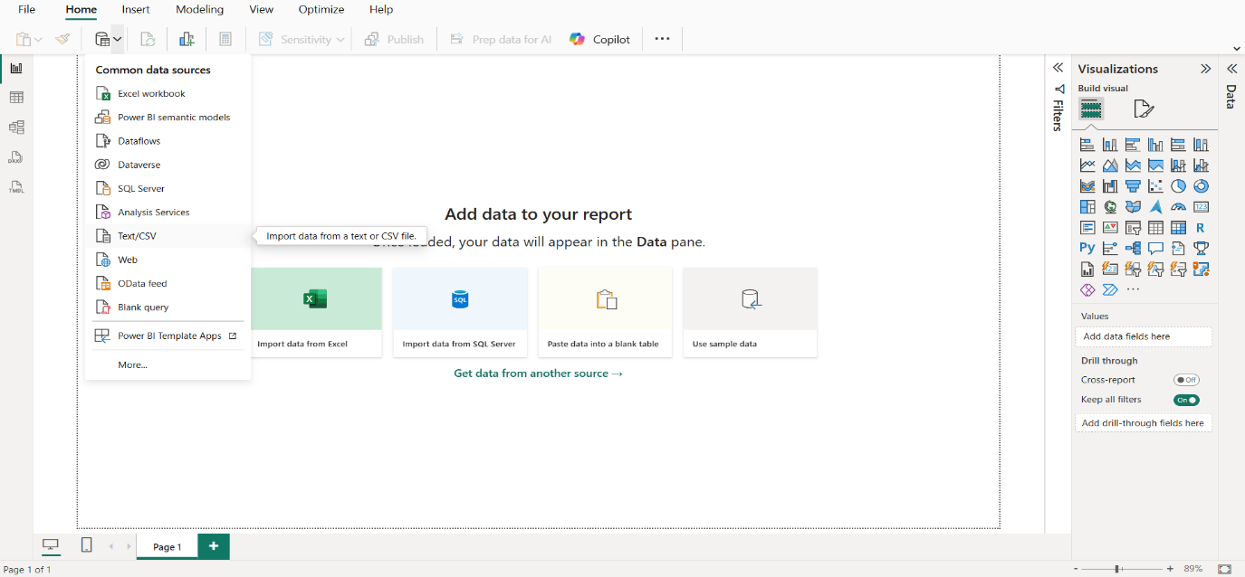

2). Transforming data to clean dataset with the help of Power Query Editor

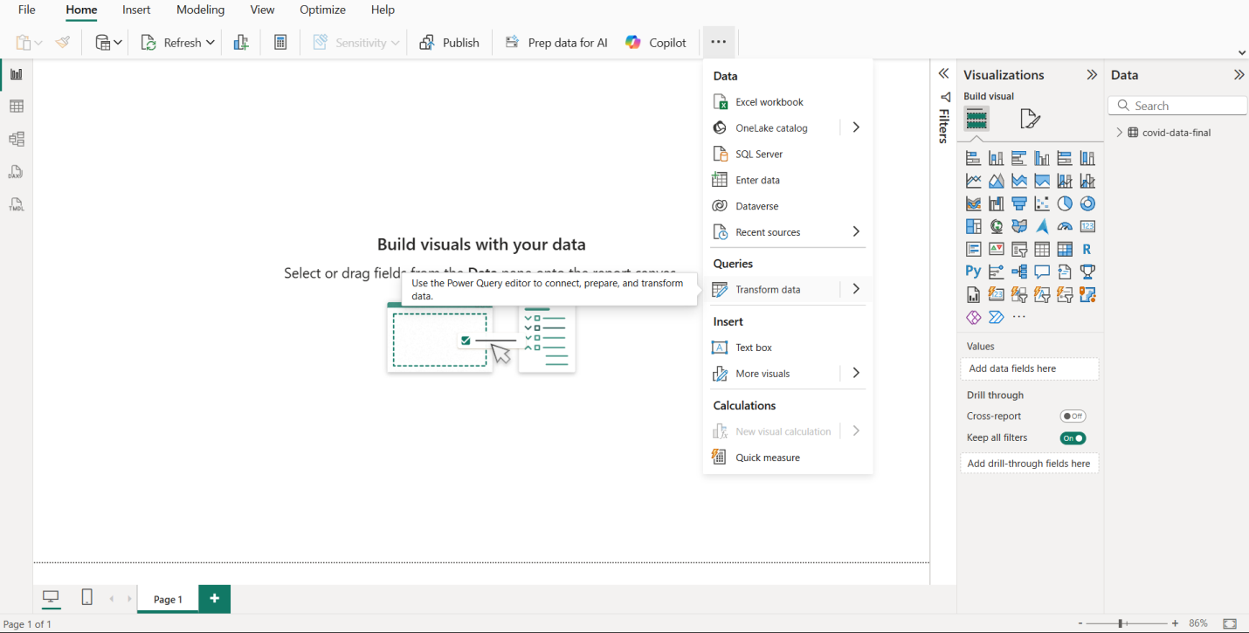

3). Data Visualization

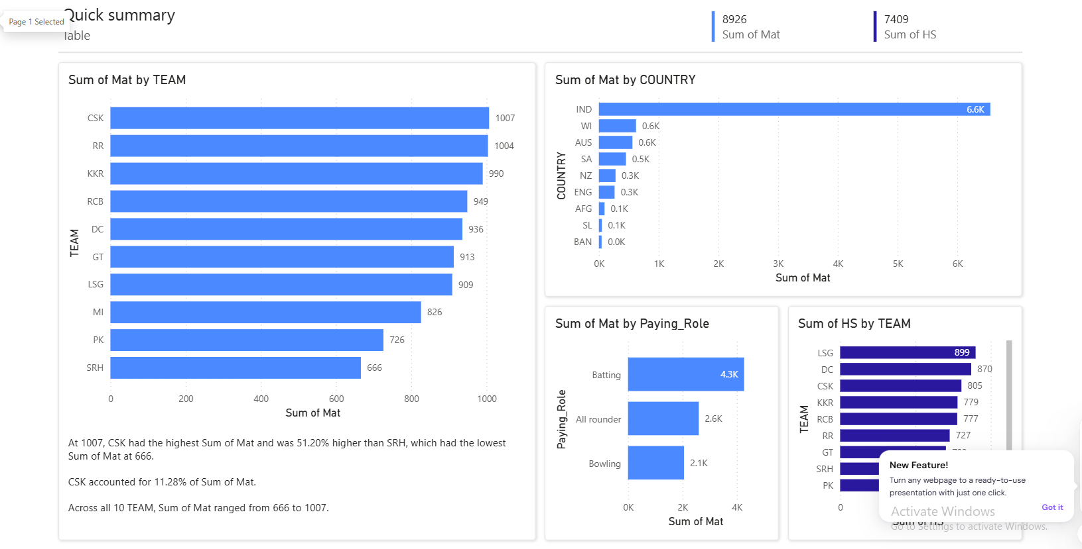

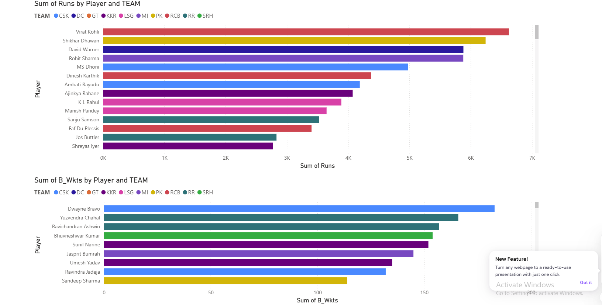

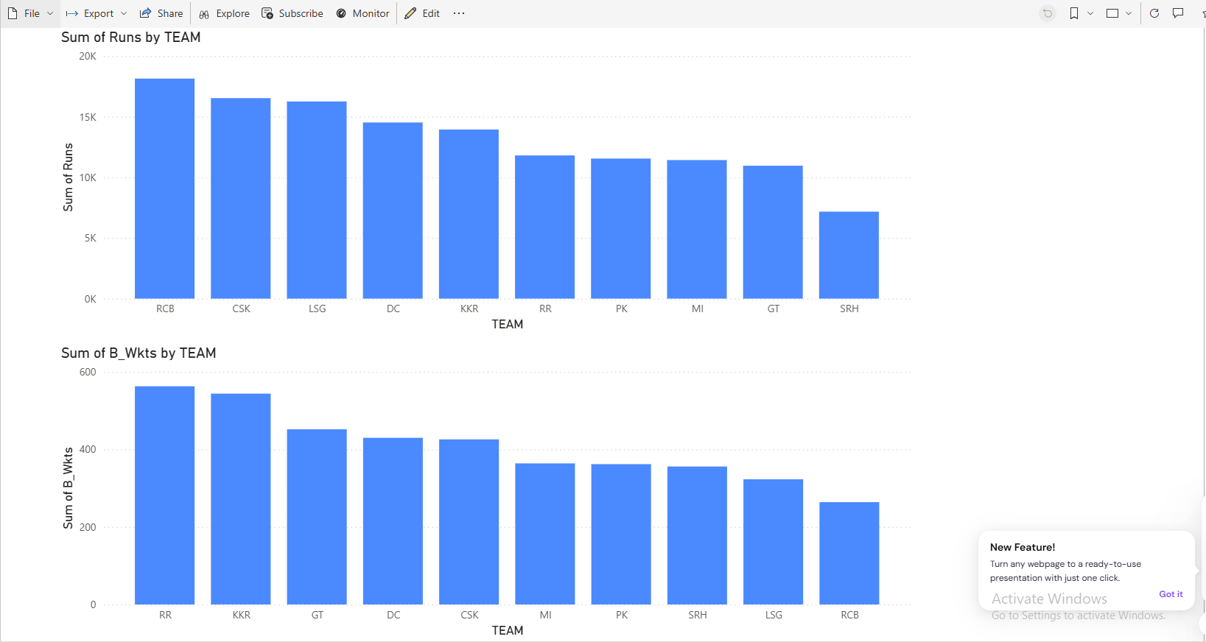
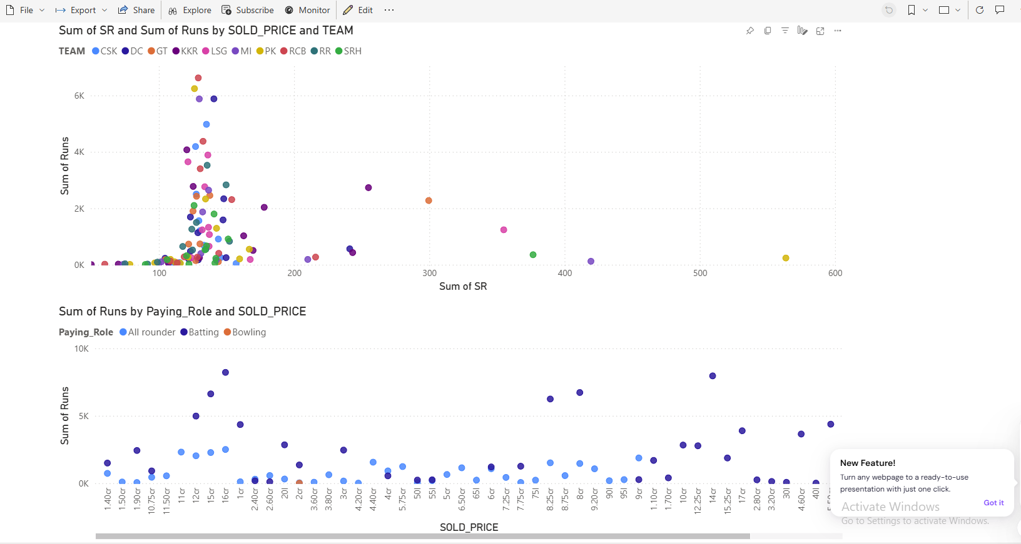
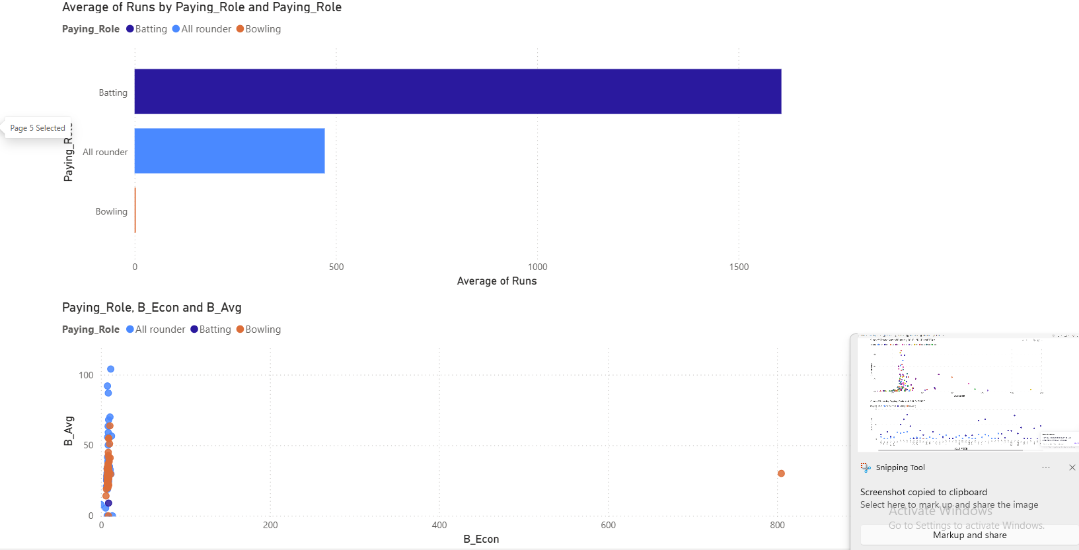

RESULT:-
All the required visuals were successfully created and combined into a single interactive Power BI Dashboard. The dashboard provides a comprehensive and clear view of sales performance, profit trends, and regional insights.

